

# 19BIT0292

**Bhaumik Tandan**

DIGITAL ASSIGNMENT

OPEN SOURCE PROGRAMING

ITE1008

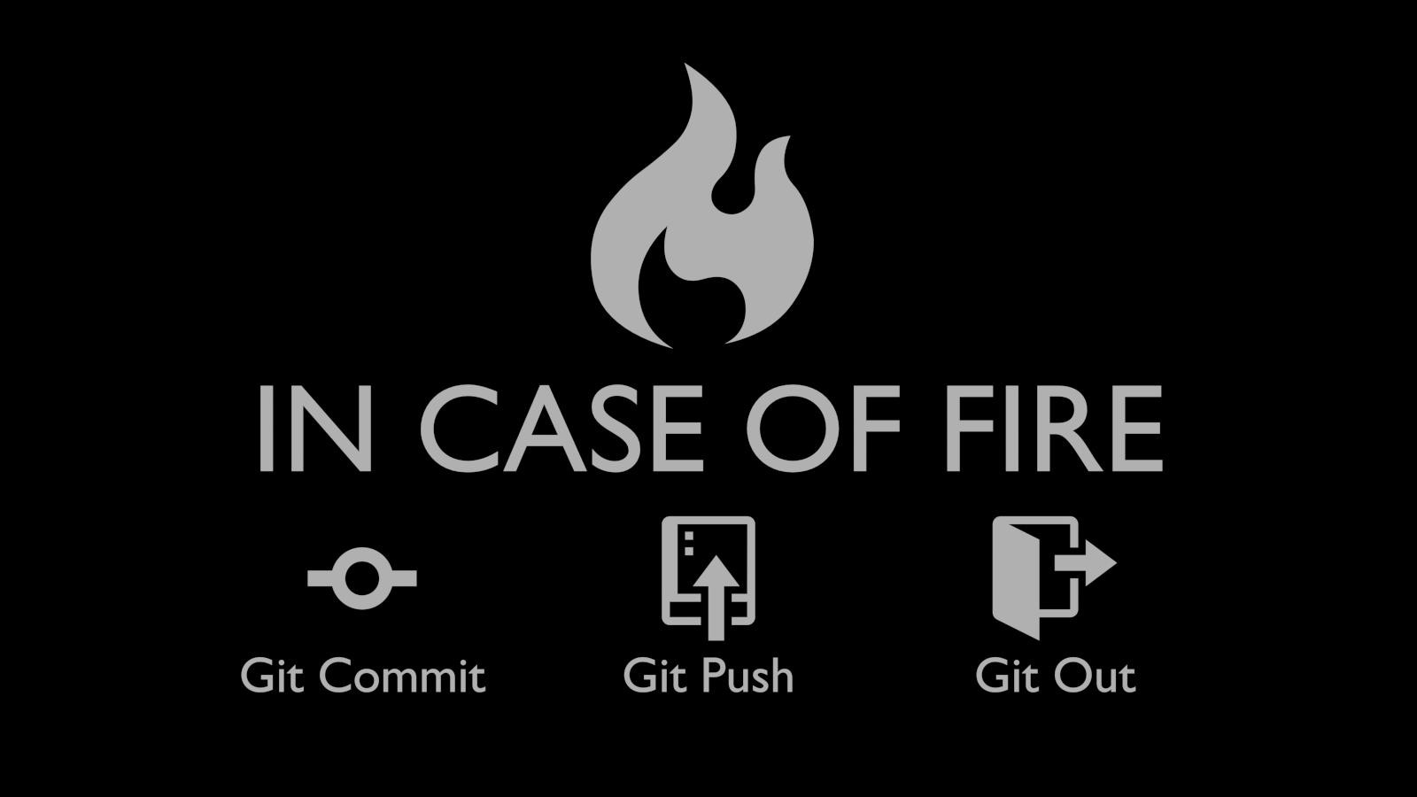

GIT

**ABSTRACT**

This document talks about git, which a distributed version control system (vcs), as well a source code management(scm).

It keep tracks of all the versions of files of the project,  
as well as it also help us to role back to each version of it.  
From 1991 to 2002 the changes in the development of Linux kernel were passed through archives and patches.

Then in 2002 they began to use BitKeeper, which revoked it's free status in 2005. So there was in a crisis in the collaborative development of Linux. Then the main developer of Linux kernal, Linux Torvalds came with the idea of Git.

After he launched git on 7th April, 2005, it revolutionized not only the development of linux but also most of the open source softwares.

This document contains the basic commands of git. As now a days the storage space is abundant, it can not only be used by developers for souce code management , but common users can also use it to keep all the version of their documents and file.

**INTRODUCTION**

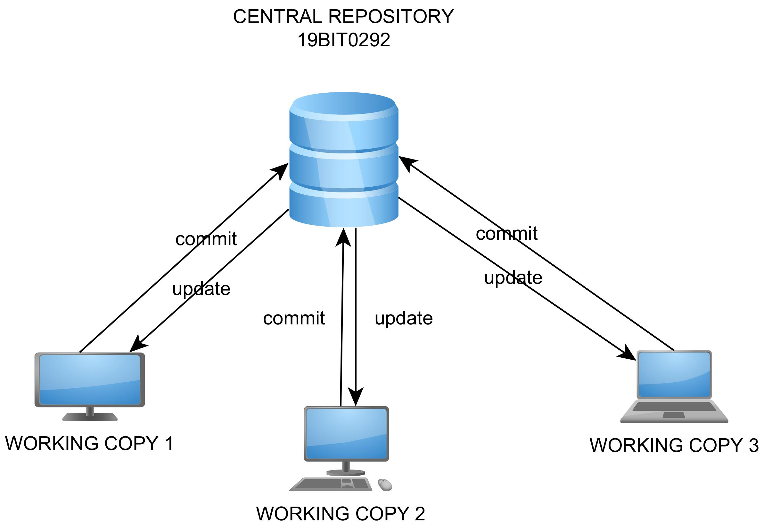All the changes and history of the folder is stored in a .git folder called respository. In a centralised version control system there is a central repository in a system and all the code contributers update their changes in the central server.  
The problem in this was the if something happens to to central server so the whole progress of the project is lost.

But in case of distributed version control system like git there is a copy of the whole respository with each remote system and when needed they match their repository with a central repository hosted on a server or any cloud server provider like GitHub, gitlab, etc.



In git a file can be on one of the four stages:-

1)Untracked file:- A file in this stage does not get tracked and any changes made to it are not the part of our repository.

2)Modified file:- File in this stage are getting tracked but have been modified after the last commit.

3)Committed file:- This file is up to date with our current repository

4)Staged file:- These files are ready to get committed.



We have to note that backups are not automatically made in case of git we have run some commands to do that. With respect to git in general we can categories our work space into 4 parts:-

1)Working directory:- This is the normal working space in our computer.

2)Staging Area:- Files in this area are ready to get committed.

3)Local Repository:- Files in this area are committed and stored in a version of the project.

4)Remote repository:-Files in this area are in any kind of remote centralized server or repository hosting website like GitHub, GitLab, etc.



**DEMONSTRATION STEPS**

**INSTALATION**

GIT comes preinstalled in Linux and Mackintosh whereas in case of windows we have to install it from [here](https://github.com/git-for-windows/git/releases/download/v2.31.1.windows.1/Git-2.31.1-64-bit.exe).

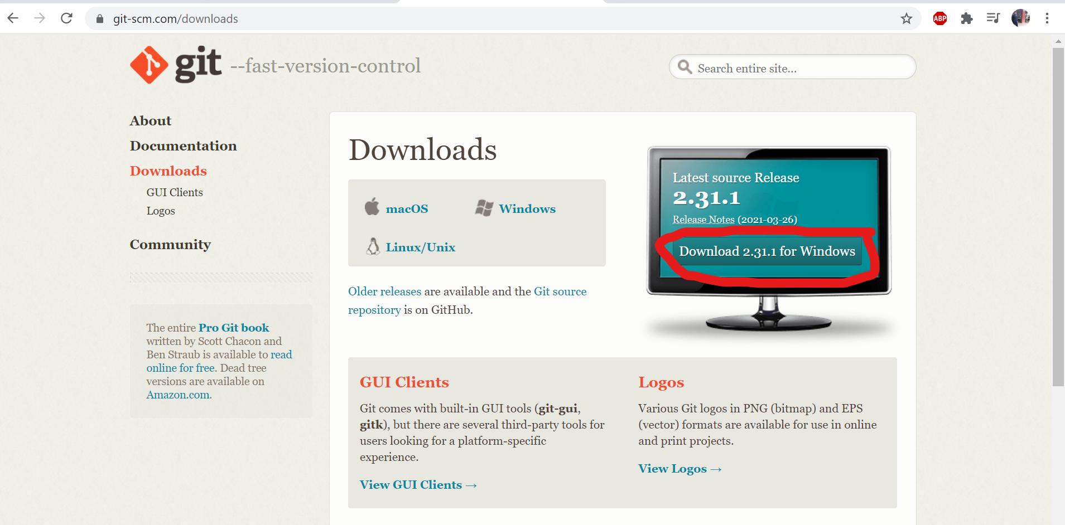

We can use any terminal in the system as well as we can also use GIT GUI, but in this demonstration we will use git bash. Open the folder and right click and select the option **“Git Bash Here”**

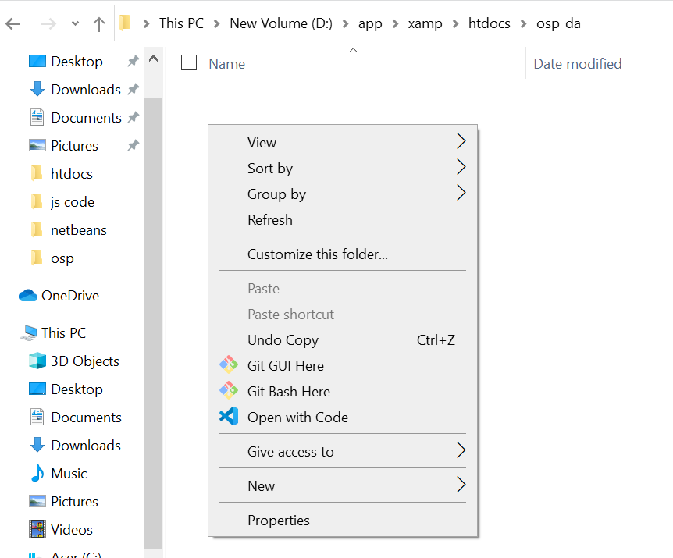

A terminal will open on that path as shown bellow

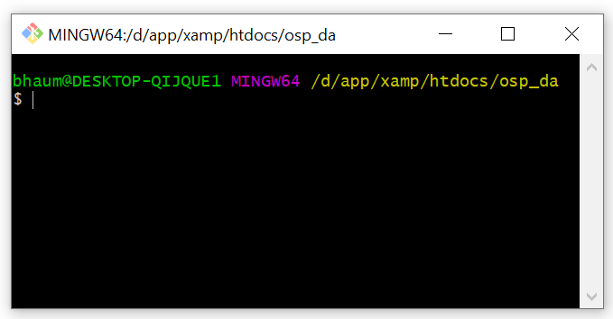

**INITIATING A REPOSITORY**

A new repository can be initiated in the folder by entering the command **git init**.

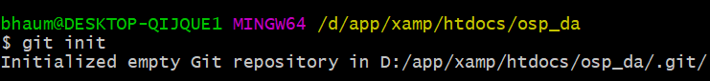

After entering the command we will observe that a new repository will be initiated in the folder and we will observe a folder labeled **“.git”** in the folder.

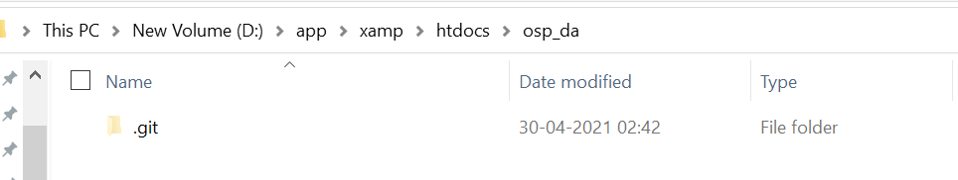

**CREATING A PROJECT WITH GIT**

We will create a login form, and with the help of which we will understand the use of git.

Suppose we have the following php file in our folder and we want to track changes using git here.

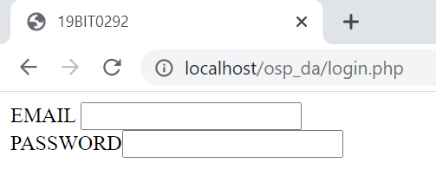<html>

<head>

<title>19BIT0292</title>

</head>

<body>

<form>

EMAIL

<input type="text" name="em"><br>

PASSWORD<input type="password">

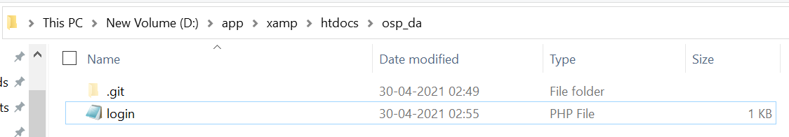</form>

</body>

</html>

In order to know the current status of the repository we can use the command We will **git status**.

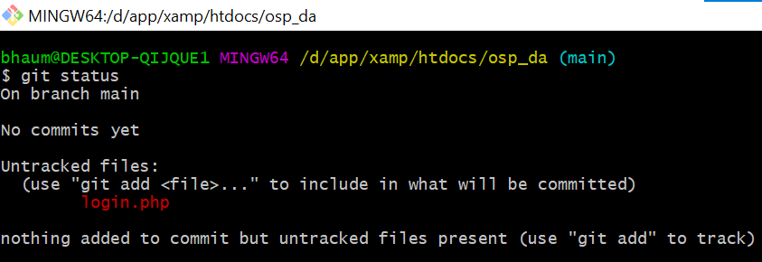

As we can see in the image above git is telling us that we have an untracked file named login.php and in order to add it to the staging area we have to run the command **git add login.php**.

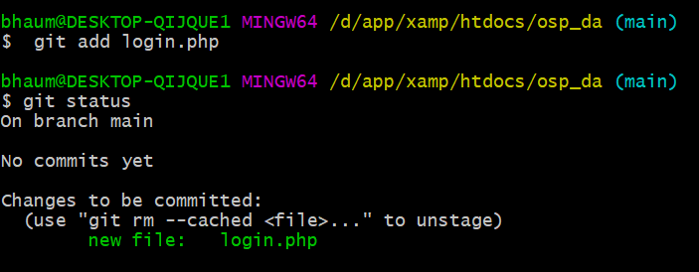

As we can see now the file has been added to the staging area.

Now we save the current version of the file using command **git commit login.php**.

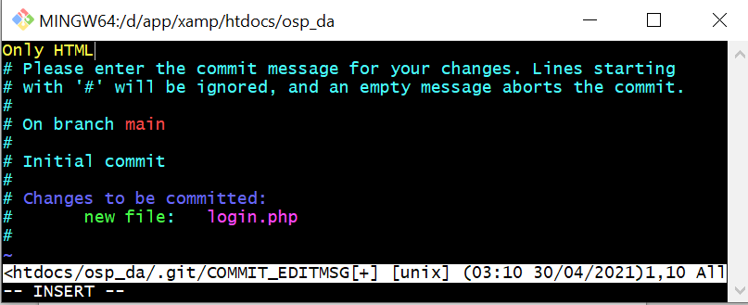

On entering the command we will observe that vim editor gets open and we can give the name to our commit.

If we want to see the log of all the commits we can use the command **git log**.

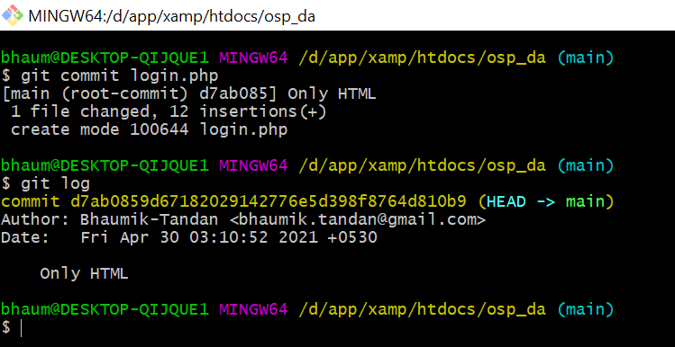

Our current version has been saved to the repository, now let's add some php to our script, display message if the email id and password matches our current password and also add an image to our login page.

After doing all the changes, the current status of our directory is:

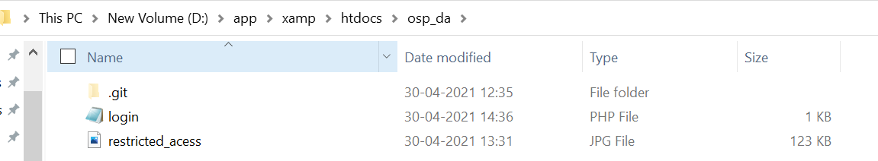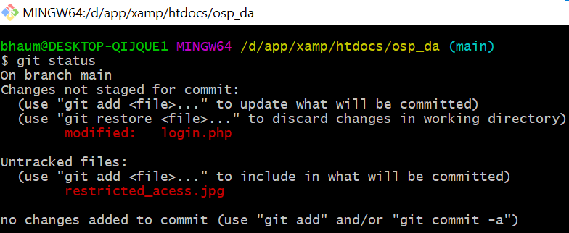

**CODE IN login.php**

<html>

<head>

<title>19BIT0292</title>

</head>

<body>

<img src="restricted_acess.jpg" alt="restrcted acess" width="300">

<form method="post">

EMAIL

<input type="text" name="em"><br>

PASSWORD<input type="password" name="pas"><br>

<button type="submit">Sign In</button>

</form>

<?php

if ($_SERVER["REQUEST_METHOD"] == "POST")

{

$email = $_POST['em'];

$password = $_POST['pas'];

if ($email=="bhaumik.tandan@gmail.com" && $password=="19BIT0292")

{

echo "WELCOME";

}

else

echo "WRONG CREDENTIALS";

}

?>

</body>

</html>

**OUTPUT**

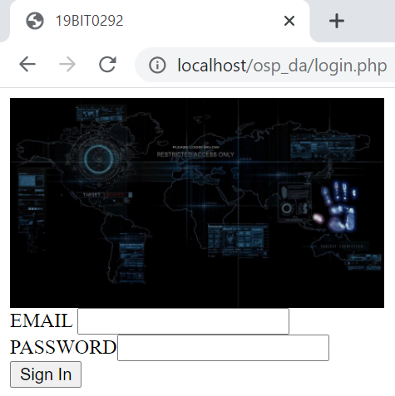

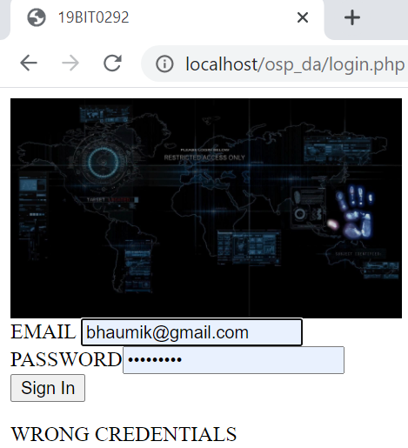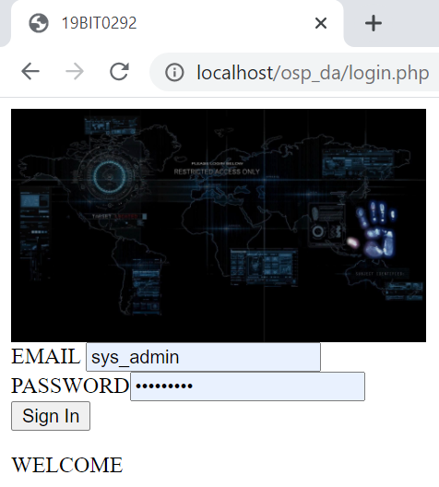

After doing all these changes in our directory, we have to first stage all the changes and then commit it, last time we only had a single file, now inspite of staging the file one by one we will stage all the files by command **git add .** .

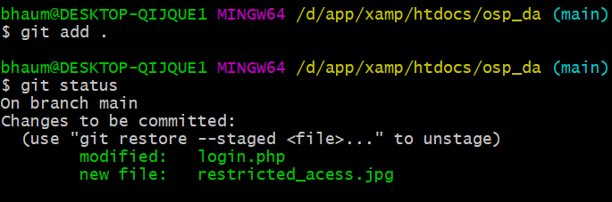

In place of writing “git commit” and then writing the message, we can directly give the name to the commit by writing the command **git commit -m “[Message]”**.

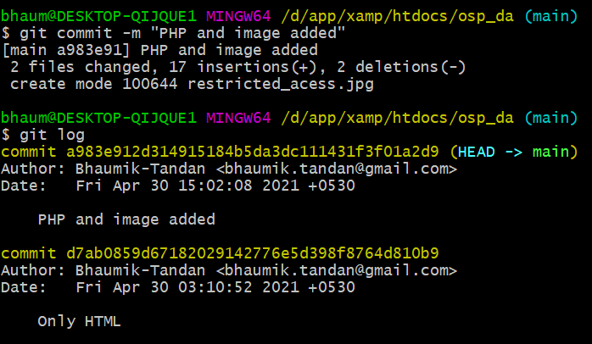

If suppose our image and file got deleted by mistake then we can match out current working directory and thus all our files will come back by using command **git checkout -f**.

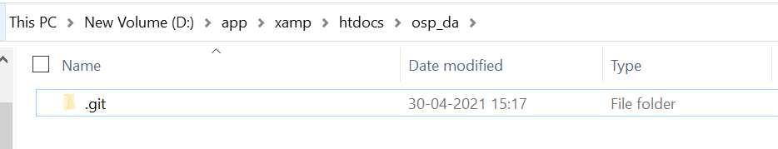

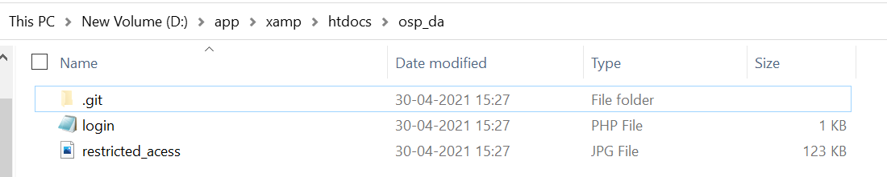If we want to match only a particular file with the last commit we can also use the command **git checkout [file name]**.

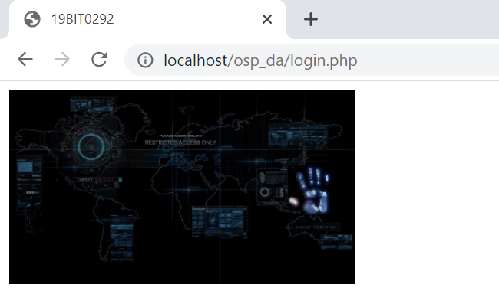

Suppose by mistake (as shown above) we deleted the form in “login.php”, we can go back to the last stage by command

**git checkout login.php**.

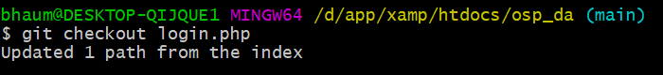

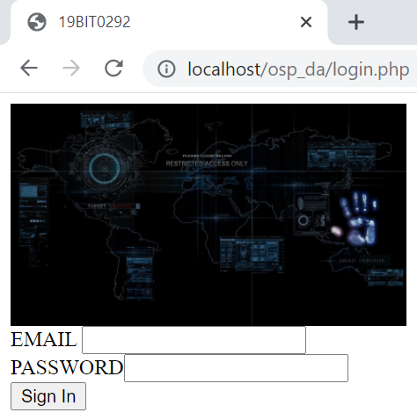

We can unstage our files by writing the command

**git restore -–staged [file_name]**.

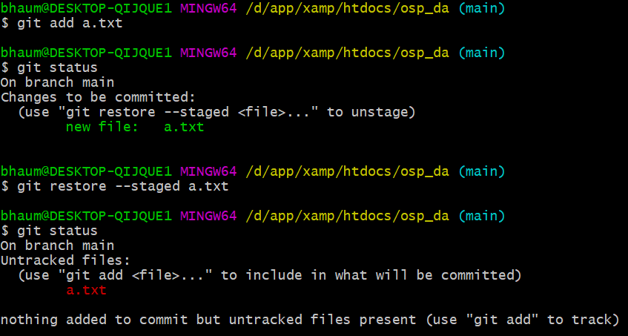

**PUSHING TO REMOTE REPOSITORY**

We already have repository, now lets push it on any cloud repository, we will use GitHubb for the same.

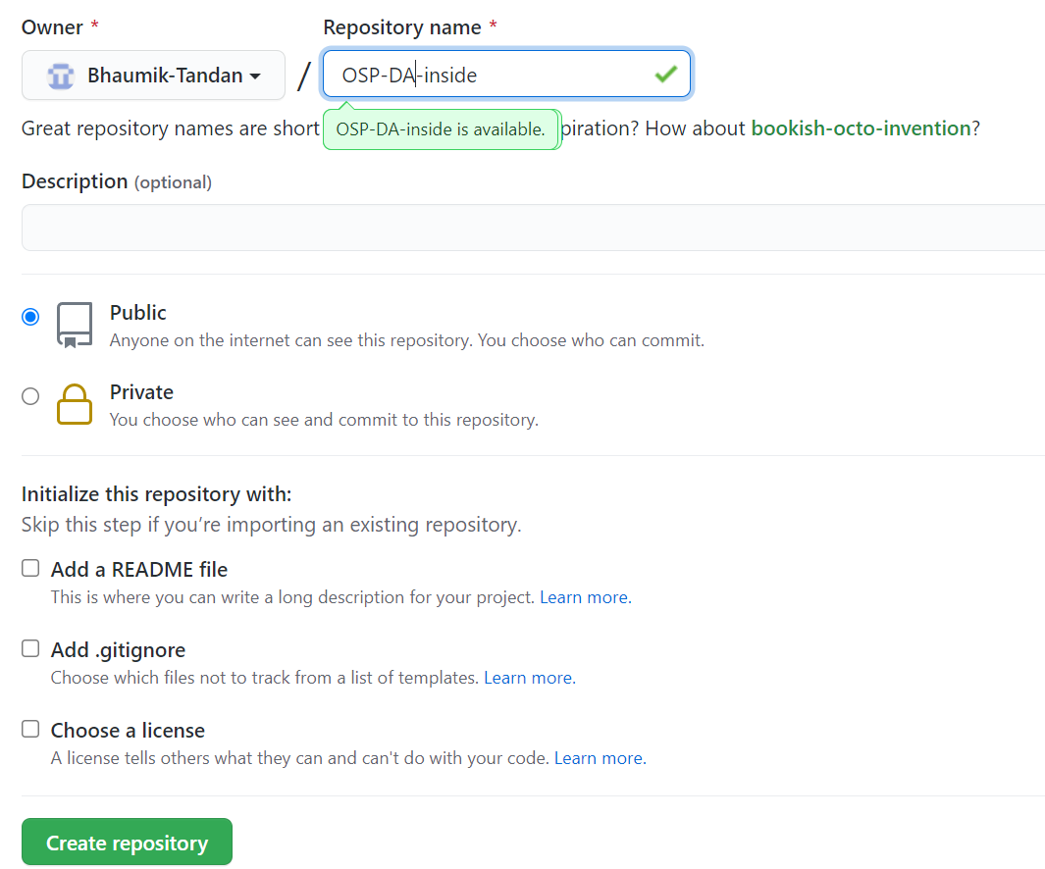

After creating a repository we will get a link like here we git:- <https://github.com/Bhaumik-Tandan/OSP-DA-inside.git>

We can push the repository to the above link by writing the command **git push -u main [link]**.

Note that is used **-u** because if we want to again update the repository so we just have to write **git push**.

